Project - Hangman Game

Your script must be named projectgame.py

For instructions how to play hangman game:   
<https://www.wikihow.com/Play-Hangman>

Video:  
<https://www.youtube.com/watch?v=cGOeiQfjYPk>

I created for you the hangman module for the graphical version and the console version.

I also provide you the pictures.

This is what my game looks like with tkinter:

Note: for the buttons you can use **an array** to store them, and **a for loop** to create them.

<https://stackoverflow.com/questions/10865116/tkinter-creating-buttons-in-for-loop-passing-command-arguments>

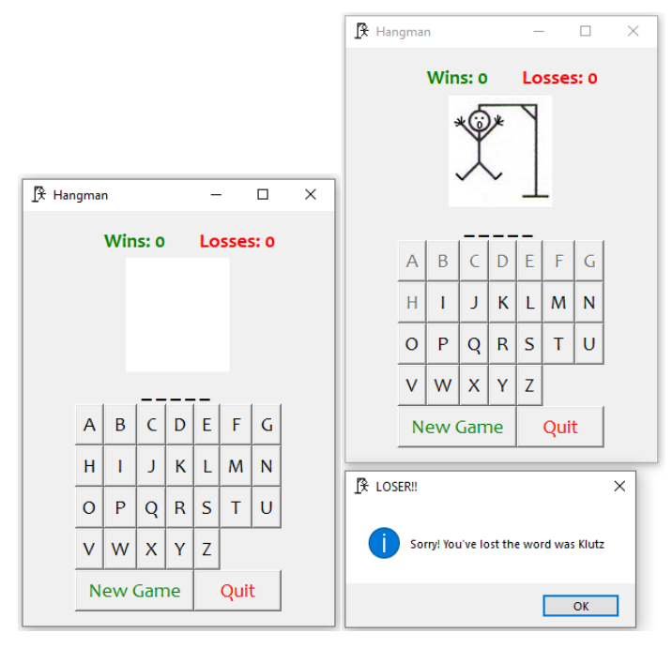

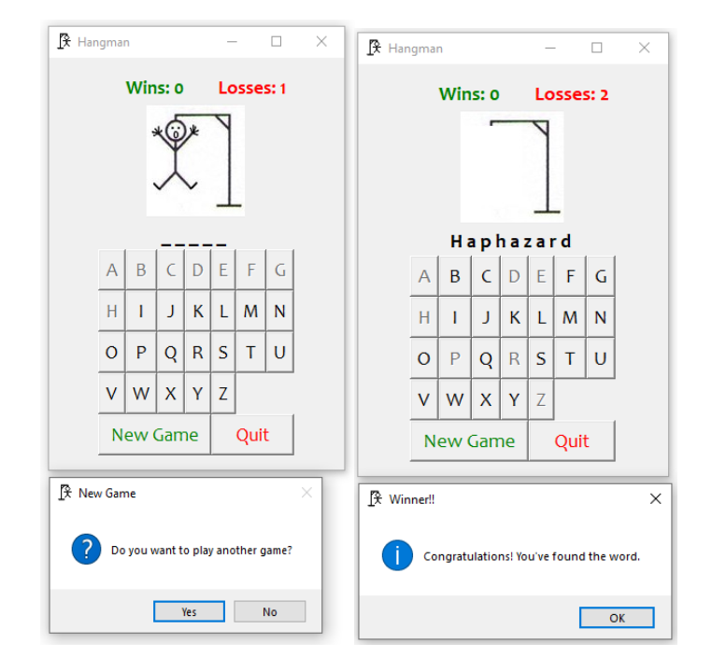

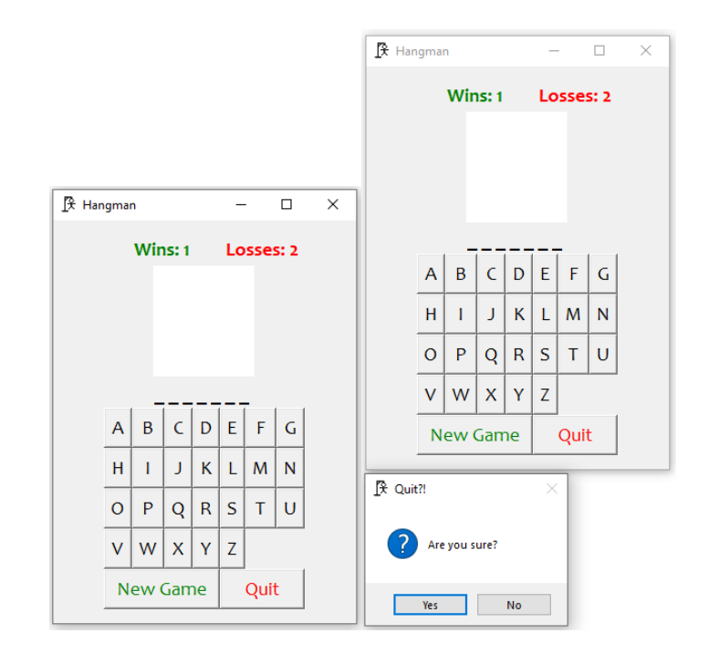

This is what my game looks like in console

Hangman by (your name)

